REPORT ON
U18IT707: MAJOR PROJECT WORK PHASE-I

STUDENT PERFORMANCE PREDICTION APPROACH BASED ON EDUCATIONAL DATA MINING

Submitted to
the faculty of Engineering and Technology of Kakatiya University, Warangal
in partial fulfilment of the requirements to award
Bachelor of Technology in
Information Technology
BY

B21IT034 BHARATH KUMAR

B21IT053 AKSHAYA B21IT033 SAI ROHANTH B21IT040 ROHAN

UNDER THE GUIDANCE OF Sri. Gautam Rampalli
Assistant Professor, Dept. of I.T.

DEPARTMENT OF INFORMATION TECHNOLOGY KAKATIYA INSTITUTE OF TECHNOLOGY & SCIENCE, WARANGAL-15

(An Autonomous Institute under Kakatiya University) 2024 - 2025



C E R T I F I C A T E

This is to certify that P. Bharath Kumar (B21IT034), B. Akshaya (B21IT053), P. Sai Rohanth (B21IT033), P. Rohan (B21IT040) of VII-Semester B.Tech. Information Technology has satisfactorily completed the U18IT804: MAJOR PROJECT WORK PHASE-I entitled “ENHANCING UNIVERSITY ADMISSIONS THROUGH PREDICTIVE DATA MINING
FOR STUDENT PERFORMANCE ANALYSIS” in the partial fulfilment of the requirement of B.Tech. degree during this academic year 2024-2025.

SUPERVISOR CHAIRMAN, DMPEC

Sri. Gautam Rampalli Dr. T. SENTHIL MURUGAN
Assistant Professor ,Dept. of IT Professor & Head, Dept. of I.T.

ACKNOWLEDGEMENT

We wish to take this opportunity to express my deep gratitude to all the people who have extended their cooperation in various ways during our Major project. It is our pleasure to acknowledge the help of all those individuals.
We thank Dr. K. ASHOKA REDDY, Principal of Kakatiya Institute of Technology & Science, Warangal, for his strong support.
We thank Dr. T. SENTHIL MURUGAN, Professor & Head, Department of Information Technology for his constant support in bringing shape to this Major project.
We would like to thank our supervisor Sri. Gautam Rampalli, Assistant Professor of Information Technology for his guidance and help throughout the Major project.
In completing this Major project successfully all our faculty members have given an excellent cooperation by guiding us in every aspect. All your guidance helped us a lot and I am very grateful to you.

BATCH-08

[B21IT034] | BHARATH KUMAR
[B21IT053] | AKSHAYA
[B21IT033] | SAI ROHANTH
[B21IT040] | ROHAN

ABSTRACT

Admissions processes in higher education institutions play a pivotal role in selecting candidates with the potential to excel academically. This study explores data mining techniques for universities admission decision support. Existing system consists of four prominent machine learning techniques, namely Artificial Neural Network ,Decision Tree, Support Vector Machine, Gaussian Naive Bayes, Gradient Boosting ,K-Nearest Neighbors, Random Forest, Logistic Regression. Real student dataset inputs form the basis of this comparative analysis. This stage aims to establish the accuracy and effectiveness of these techniques in predicting academic outcomes. The study proposes a multiclass prediction model, addressing overfitting and misclassification challenges in imbalanced multiclass classification using an innovative approach. By presenting a comparative analysis of machine learning techniques and proposing a sophisticated multiclass prediction model, the study contributes to the advancement of admissions decision-making processes in higher education. Research provides universities with tools to refine selection criteria for academic success.

 |  | CONTENTS
CHAPTERNO. |  | TITLE | PAGE NO.
1. | Introduction |  | 01
 | 1.1 Background and Context |  | 01
 | 1.2 Objectives |  | 02
2. | Literature Survey |  | 04
3. | Existing Method |  | 06
4. | Proposed Method |  | 07
 | 4.1 Methodology |  | 08
 | 4.1.1 | Data Collection | 08
 | 4.1.2 | Data Exploration | 08
 | 4.1.3 | Data Preprocessing | 08
 | 4.1.4 | Train-Test Split | 08
 | 4.1.5 | Predicting Early Academic Performance | 08
 | 4.1.6 | Identifying Admission Criteria | 09
 | 4.1.7 | Determining the best Data Mining Technique | 09
 | 4.1.8 | Model Evaluation | 10
5. | Results and Discussion |  | 11
 | 5.1 Method Evaluation |  | 12
6. | Conclusion and future scope |  | 18
 | References |  | 19

LIST OF FIGURES

FIGURE NO. | FIGURE NAME | PAGE NO.
3.1 | Classifier Performance | 06
4.1 | Architecture | 09
5.1 | Dataset | 11
5.2 | Precision Comparison | 13
5.3 | Recall Comparison | 14
5.4 | Accuracy Comparison | 15
5.5 | Comparison of Performance Metrics | 17

CHAPTER 1 INTRODUCTION
The necessity for effective decision support systems in university admission processes has become increasingly obvious in the fast expanding higher education landscape. With the increasing number of student data, there is a chance to use advanced analytical tools, notably data mining, to improve the accuracy and efficiency of admission decisions. The goal of this research is to investigate the use of data mining techniques to forecast student performance, hence offering significant insights for decision-making in university admission systems.

BACKGROUND AND CONTEXT

University admissions procedures shape the academic landscape by selecting students who have the capacity to succeed in a certain academic program. Historically, these judgments were made using a variety of criteria, such as academic records, standardized test scores, and personal statements. The dynamic and diverse nature of student success, on the other hand, suggests that a more sophisticated approach is required.
Data mining integration into admissions procedures provides a data-driven answer to this difficulty. Institutions can make more informed selections by evaluating historical data and discovering trends within varied sets of student information, so streamlining the selection process and assuring a better fit between students and academic programs.
Data mining, the process of detecting patterns and extracting useful information from massive databases, has found widespread application in a variety of fields, including education. Data mining approaches have the ability to identify hidden correlations between admission criteria and subsequent academic success in the context of university admissions. These strategies can help identify crucial characteristics that have a substantial impact on a student's academic trajectory. Institutions can improve the accuracy of their admission decisions by doing so, resulting in a better fit between students and academic programs.

OBJECTIVES

Identification of Optimal Admission Criteria:

    - Examine the statistics to see if you can identify the admission criterion that best predicts applicants' future academic success.
    - Examine the relationship between various admission criteria and subsequent academic success to identify the most relevant factors.

Prediction of Early Academic Performance:
    - Investigate the viability of forecasting candidates' early academic performance prior to admission, with a focus on pre-admission test scores as predictive variables.
    - Create and train a predictive model to predict applicants' academic achievement based on their pre-admission exam scores.

Impact of Weighted Admission Criteria on First-Year Performance:

    - Examine whether students' first-year academic performance improves when the most important admission factor is given greater weight.
    - Experiment with various weighting algorithms for admission criteria and evaluate their impact on admitted students' subsequent academic results.

Model Evaluation and Interpretability:

    - Analyze the predictive model's performance in terms of accuracy, precision, recall, and other important metrics.
    - The data should be interpreted to see how well the model reflects the intricacies of early academic achievement prediction.

Integration with Admission Systems:

    - Investigate the feasibility of using the developed model into university admissions systems.

    - Ensure that the prediction model matches with practical considerations and is user-friendly for admissions administrators.

Continuous Improvement and Ethical Considerations:

    - Create techniques for continual model improvement based on fresh data and feedback.

    - Consider ethical issues such as fairness, openness, and potential biases when using data mining for decision support in university admissions.

CHAPTER 2 LITERATURE SURVEY
Author | Paper Title | Methodology | Advantages | Disadvantages
M. O. Al-  Rukban, F. M. Munshi, H. Abdulghani, and I. Al-  Hoqail, | The ability of the pre-  admission criteria to predict  performance in a Saudi  medical school | Four sets were used to examine the predictive power of preadmission variables. | Predictive insights. | Retrospective design limitations.
D.  Kabakchieva | Predicting student  performance by using data mining  methods for classification | Cyclic approach, including six main phases –  Business Understanding, Data Understanding, Data Preparation, Modeling, Evaluation and  Deployment. | Insights via data mining. | Dataset and algorithm limitations.
V. L. Miguéis,  A. Freitas, P. J.  V. Garcia, and  A. Silva | Early  segmentation of students according to their academic  performance: A predictive  modeling approach | Used a binning algorithm (equal-width binning) to establish five levels of academic performance. | Early  performance segmentation insights. | Potential predictive model  limitations.
Adejo,  Olugbenga & Connolly,  Thomas | An Integrated System  Framework for Predicting  Students' Academic  Performance in Higher | Describes the algorithm selective processes that occur in the modelling engine stage in order to select the best predictive modellers. | Holistic academic  performance prediction. | Potential  implementation complexities.

 | Educational Institutions
H. Guruler, A. Istanbullu, and  M. Karahasan | A new student performance analysing system using knowledge  discovery in higher  educational databases,'' | Knowledge discovery applied on university students’ demographical data | Enhanced student  performance analysis | Possible data complexity challenges.
Gabriela czibula | A Machine Learning- Based  Framework for Enhancing the performance of Decision-  Making  Processes | Introduces the methodology for developing  the IntelliDaM framework | Improved decision- making through machine learning. | Possible model complexity issues.
Essa Alhazmi | Early  Predicting of Students  Performance in Higher  Education | Xgboost , Logistic  Recognition , Support Vector Machine, K nearst neighbor and Random Forest | Early  performance anticipation. | Potential predictive model  limitations.
Amirah Mohamed Shahiri | A Review on Predicting Student’s Performance using Data Mining  Techniques | Neural Network and Decision Tree are the two methods highly used for predicting student  performance | Summarizes data mining's predictive efficacy. | Potential bias or limited datasets.
Geraldine Gray | An application of  classification models to  predict learner progression in tertiary  education | Determining psychometric factors and model  accuracies of SVM ,ANN  ,Decision tree ,Naïve Bayes , Logistic  Regression. | Provides predictive learner  progression insights. | Potential model bias or  overfitting risk.

CHAPTER 3 EXISTING METHOD
Four prediction models were proposed and constructed utilizing four well-known data mining techniques: the Artificial Neural Network (ANN), the Decision Tree, the Support Vector Machine (SVM), and the Naive Bayes. The study used a dataset of 2,039 student records from PNU, one of the largest universities in Saudi Arabia. However, the strategies adopted are generic and can be applied in any higher education institution. The study validates the efficacy of prediction modeling in higher education institutions, where decision makers can utilize these models to plan and optimize the institutions' restricted resource allocations.
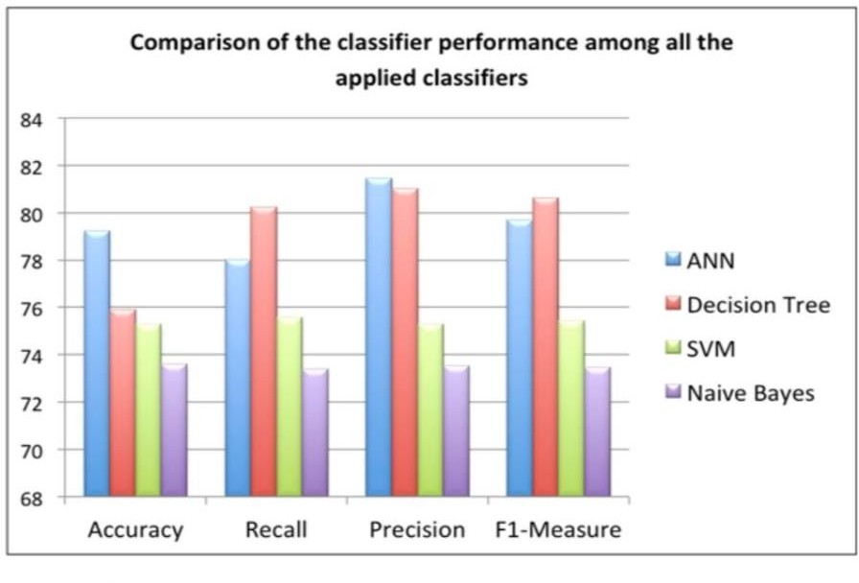
Fig. 3.1 Classifier Performance

This study concludes that the SAAT score is the admission criterion that most correctly predicts later academic success and that it should thus be given more weight. Based on this proposal, decision makers at PNU, where this study was conducted, examined the admission system and decided to change the weights of the three entrance factors listed in this study by giving a higher weight to the SAAT score.Furthermore, the study's findings demonstrate that the ANN technique exceeds the others in both accuracy and precision metrics, while the Decision Tree technique outperforms the others in recall and F1-Measure. The Naive Bayes method produced the worst results.

CHAPTER 4 PROPOSED METHOD

Predicting Early Academic Performance:

The primary objective of the system is to predict applicants' early academic performance before admitting them to the university. By analyzing pre-admission test scores and other relevant factors, the system aims to forecast how well applicants are likely to perform academically once admitted.

Identifying Admission Criteria:

In addition to predicting academic performance, the system seeks to identify the admission criteria that most accurately predict applicants' future academic success. By exploring the relationship between various independent variables (such as test scores, demographic information, etc.) and the dependent variable (academic performance), the system aims to pinpoint the factors most indicative of academic potential.

Determining the Best Data Mining Technique:

Another objective of the system is to determine the best-performing data mining technique for the predictive task at hand. By experimenting with a range of techniques such as Artificial Neural Networks, Decision Trees, Regression models, and others, the system aims to identify the approach that yields the most accurate and reliable predictions.

Enhancing Decision-Making Processes:

Ultimately, the system aims to provide decision support to admission committees by offering insights into applicants' potential academic performance. By leveraging predictive models and data analysis, the system empowers admission committees to make more informed and objective decisions regarding applicant selection, thereby improving the overall quality and fairness of the admission process.

METHODOLOGY
    - Data Collection
Gather previous data on student performance, including academic achievements, standardized test scores, extracurricular activities, and any other pertinent information.

    - Data Exploration
Explore and analyze the dataset to understand the distribution of student performance labels. Identify any imbalance between classes. It involves understanding the distribution of variables, identifying potential issues, and informing decisions for subsequent steps in the machine learning workflow.

    - Data Preprocessing
Identify and handle missing values through methods such as imputation removal of columns, or more advanced imputation techniques. Detect and remove duplicate records if present in the dataset to ensure data integrity. Identify and correct inconsistencies or errors in the data, such as typos, variations in capitalization, or inconsistent formats.

    - Train-Test Split

It involves dividing the dataset into two subsets: one for training the model and the other for evaluating its performance. This process helps assess how well the model generalizes to new, unseen data.
    - Predicting Early Academic Performance

Choose appropriate regression models (e.g., Linear Regression, Random Forest Regression, Gradient Boosting Regression) for predicting early academic performance. Train the selected models using the training dataset. Evaluate the performance of each model using metrics such as Mean Squared Error (MSE), Root Mean Squared Error (RMSE), and R-squared on the testing dataset. Select the model with the best performance for predicting early academic performance.

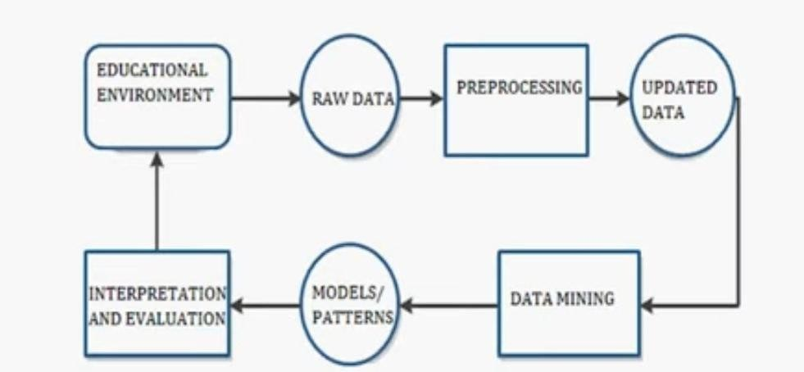

Figure 4.1 Architecture

    - Identifying Admission Criteria

Conduct feature importance analysis or correlation analysis to identify admission criteria that are most strongly correlated with early academic performance. Utilize techniques such as decision trees, random forests, or gradient boosting to determine the importance of each feature in predicting early academic performance. Prioritize admission criteria based on their importance and relevance to academic success.
    - Determining the Best Data Mining Technique

Experiment with various data mining techniques, including regression models (e.g., Linear Regression, Random Forest Regression, Gradient Boosting Regression), to predict early academic performance. Train each model using the training dataset and evaluate their performance using appropriate metrics. Compare the performance of different data mining techniques based on evaluation

metrics such as MSE, RMSE, and R-squared. Select the data mining technique that yields the highest predictive accuracy and reliability for predicting early academic performance.
    - Model Evaluation
Model evaluation is a crucial step to assess the performance of your machine learning model on unseen data. This code calculates various metrics such as accuracy, precision, recall, and F1 score. The confusion matrix provides a breakdown of true positive, true negative, false positive, and false negative values.

CHAPTER 5 RESULTS AND DISCUSSION
The project aims to predict First Year CGPA using different regression models based on student-related features like High School Grade Average (HSGA), Scholastic Aptitude Admission Test (SAAT), and Graduate Admission Test (GAT). Eight models were employed: Artificial Neural Network (ANN), Decision Tree, and Support Vector, Gaussian Naïve Bayes, Gradient Boosting ,K- Nearest Neighbors, Random Forest, Logistic Regression.
The dataset contains 2500 records with five columns: Name ,Gender ,Age ,Country, High School Name ,High School Location ,HSGA ,SAAT, GAT, Languages, First Generation Student
,Financial Aid Needed ,CGPA and CGPA Category.

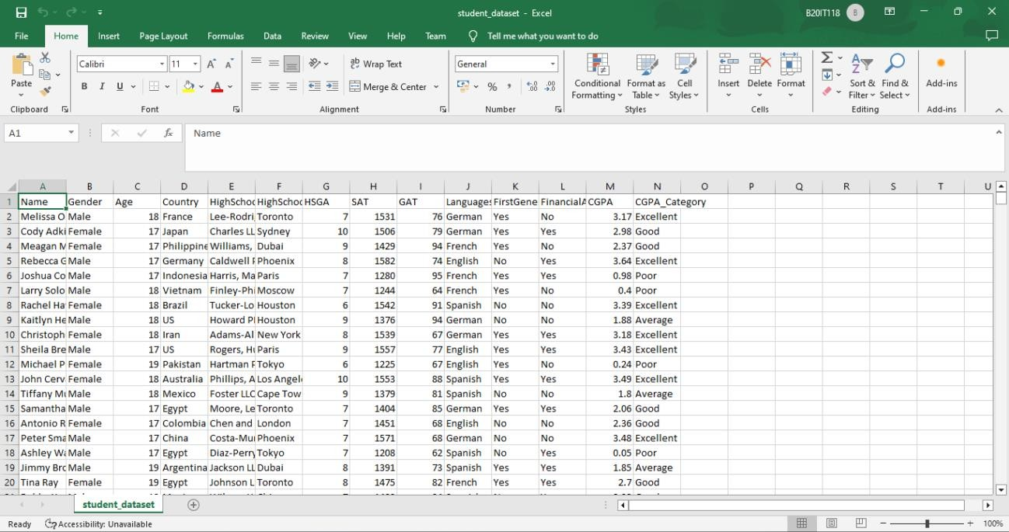

Figure 5.1 Dataset

MODEL EVALUATION

    - Artificial Neural Network (ANN)

Complex model inspired by the human brain, capable of learning intricate patterns in data. Can handle non-linear relationships effectively. Achieved the second-highest accuracy (0.988) and precision (0.98816) among the listed models. Can be computationally expensive to train and less interpretable compared to simpler models.
Performance Metrics:

      - Precision: 0.98816
      - Recall: 0.988
      - F1 Score:0.987979
      - Accuracy:0.988

5.1.2 Decision Tree

Tree-like structure where data is classified based on a series of rules. Easy to understand and interpret the decision-making process. Performed well with accuracy (0.982667) close to ANN but slightly lower precision (0.983253). Might not capture complex relationships in data as well as ANN.
Performance Metrics:

- Precision: 0.983253
- Recall: 0.982667
- F1 Score:0.982706
- Accuracy:0.982667

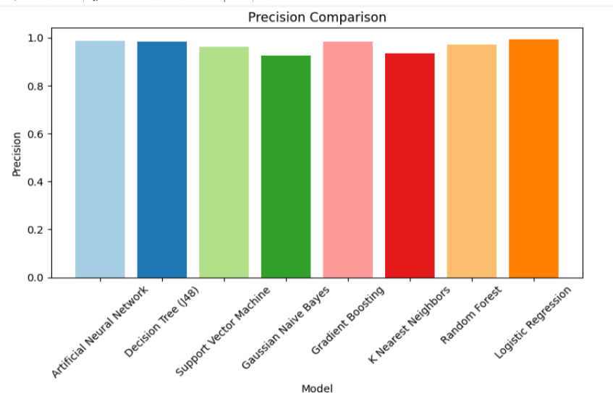

Figure 5.2 Precision Comparison

5.1.3. Support Vector Machine

Creates a hyperplane separating data points belonging to different classes. Effective for high dimensional data. Lower accuracy (0.964) compared to ANN and Decision Tree. Tuning hyperparameters can be challenging. May not be ideal for complex, non-linear data.
Performance Metrics:

- Precision: 0.964277
- Recall: 0.964
- F1 Score:0.963996
- Accuracy:0.964

    - Gaussian Naïve Bayes

Classifies data based on probabilities using a simplified Bayes' theorem approach. Efficient for large datasets. Similar performance to Decision Tree in terms of accuracy (0.982667) and precision (0.983253). Assumes independence between features, which might not always hold true. May struggle with complex data.

Performance Metrics:

      - Precision: 0.983253
      - Recall: 0.982667
      - F1 Score:0.982706
      - Accuracy:0.982667

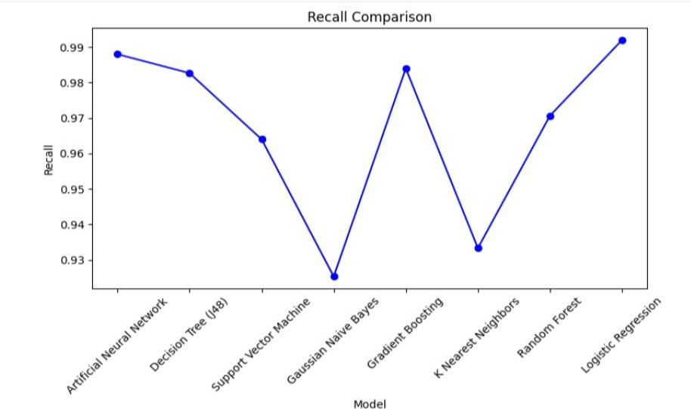

Figure 5.3 Recall Comparison

    - Gradient Boosting

Combines multiple weak decision trees into a stronger model through sequential learning. Effective for improving model accuracy over a single decision tree. Accuracy (0.984) falls between ANN and Decision Tree. Can be more complex to tune and interpret compared to a single decision tree.
Performance Metrics:

      - Precision: 0.984465

      - Recall: 0.984
      - F1 Score:0.984035
      - Accuracy:0.984

    - K-Nearest Neighbors

Classifies data points based on the similarity to their k nearest neighbors in the training data. Simple to implement. Lowest accuracy (0.933333) among the compared models. Performance can be affected by the choice of k and irrelevant features in the data. May suffer from the "curse of dimensionality" for high- dimensional datasets.
Performance Metrics:

      - Precision: 0.934357
      - Recall: 0.933333
      - F1 Score:0.933219
      - Accuracy:0.933333

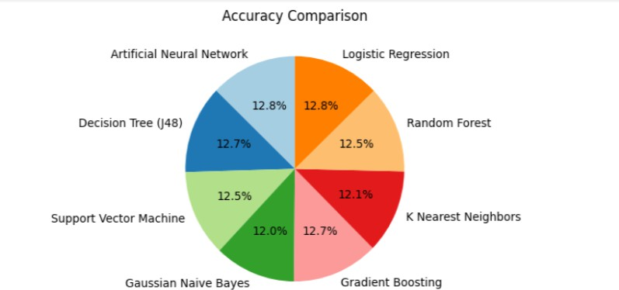

Figure 5.4 Accuracy Comparison

    - Random Forest

Ensemble learning method that combines multiple decision trees for improved performance and addressing overfitting issues. Accuracy (0.970667) falls between Decision Tree and Gradient Boosting. Can be computationally expensive to train for large datasets. Less interpretable compared to a single decision tree.
Performance Metrics:

      - Precision: 0.970845
      - Recall: 0.970667
      - F1 Score:0.970675
      - Accuracy:0.970667

    - Logistic Regression

Statistical model used for binary classification problems. Estimates the probability of an outcome based on independent variables. Easy to interpret. Achieved the second-highest accuracy (0.992) with very high precision (0.992041). Limited to binary classification tasks. May not capture complex non-linear relationships as effectively as ANNs.
Performance Metrics:

      - Precision: 0.992041
      - Recall: 0.992
      - F1 Score:0.992008
      - Accuracy:0.992

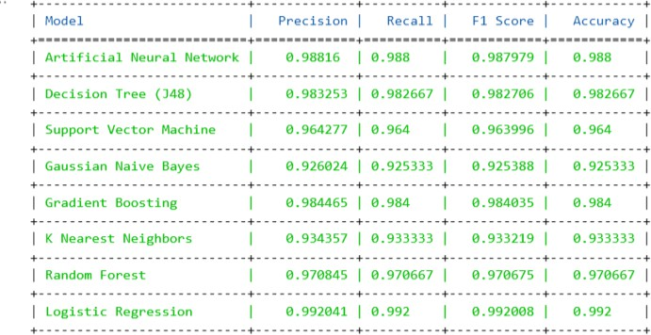

Figure 5.5 Comparison of Performance Metrics

CHAPTER 6 CONCLUSION AND FUTURE SCOPE

This study explored the potential of leveraging predictive data mining techniques to enhance university admissions processes. We evaluated eight distinct machine learning models for their effectiveness in predicting student CGPA (Cumulative Grade Point Average). This study explored the potential of leveraging predictive data mining techniques to enhance university admissions processes. We evaluated eight distinct machine learning models for their effectiveness in predicting student CGPA.
In conclusion, this investigation demonstrates the potential of data mining for enhancing university admissions. While Logistic Regression showcases impressive performance, its limitations necessitate exploring alternative models like Gradient Boosting Regression or Random Forest Regression for a more comprehensive understanding of student performance and future potential. By incorporating such data-driven approaches, universities can make more informed admissions decisions, fostering student success and enriching the overall academic experience.
The exploration of predictive data mining for university admissions offers a promising future. We can expand data sources beyond academics to include extracurriculars, online learning, and socioeconomics, creating a richer student profile. Additionally, refining predictive models through ensemble methods or deep learning can improve accuracy, especially for future scope analysis. Ethical considerations like fairness and transparency are crucial when implementing data mining practices in admissions. Furthermore, data mining insights can be used to personalize learning experiences and support struggling students. Finally, integrating data-driven insights with traditional admissions criteria can create a well-rounded process that prioritizes student potential and program fit. By continuing to develop this approach, universities can leverage data mining to create a more predictive, personalized, and successful admissions process for all students.

REFERENCES

- H. Guruler, A. Istanbullu, and M. Karahasan, ‘‘A new student performance analysing system using knowledge discovery in higher educational databases,’’ Comput. Edu., vol. 55, no. 1, pp. 247–254, Aug. 2010.
- S. K. Mohamad and Z. Tasir, ‘‘Educational data mining: A review,’’ Procedia Social Behav. Sci., vol. 97, pp. 320–324, Nov. 2013.
- A. Peña-Ayala, ‘‘Educational data mining: A survey and a data miningbased analysis of recent works,’’ Expert Syst. Appl., vol. 41, no. 4, pp. 1432–1462, Mar. 2014.
- C. Romero and S. Ventura, ‘‘Educational data mining: A review of the state of the art,’’ IEEE Trans. Syst., Man, Cybern. C, Appl. Rev., vol. 40, no. 6, pp. 601–618, Nov. 2010.
- H. Aldowah, H. Al-Samarraie, and W. M. Fauzy, ‘‘Educational data mining and learning analytics for 21st century higher education: A review and synthesis,’’ Telematics Informat., vol. 37, pp. 13–49, Apr. 2019.
- M. A. Al-Barrak and M. Al-Razgan, ‘‘Predicting students final GPA using decision trees: A case study,’’ Int. J. Inf. Edu. Technol., vol. 6, no. 7, pp. 528–533, 2016
- V. L. Miguéis, A. Freitas, P. J. V. Garcia, and A. Silva, ‘‘Early segmentation of students according to their academic performance: A predictive modelling approach,’’ Decis. Support Syst., vol. 115, pp. 36–51, Nov. 2018.
- A.-A. Dabaliz, S. Kaadan, M. M. Dabbagh, A. Barakat, M. A. Shareef, M. Al-Tannir, A. Obeidat, and A. Mohamed, ‘‘Predictive validity of preadmission assessments on medical student performance,’’Int.J.Med.Edu.,vol. 8, pp. 408–413, Nov. 2017.
- A. A. Al-Ansari and M. M. A. El Tantawi, ‘‘Predicting academic performance of dental students using perception of educational environment,’’ J. Dental Educ., vol. 79, pp. 337–344, Mar. 2015.
- A. M. Shahiri, W. Husain, and N. A. Rashid, ‘‘A review on predicting Student’s performance using data mining techniques,’’ Procedia Comput. Sci., vol. 72, pp. 414–422, Jan. 2015.

